**Author: George Kyeyune**

**Naita, Maria**

Known for her persistence and consistence Maria Naita has distinguished herself as not only a major player in Uganda’s sculpture scene, but also one who has supported many budding artists. Unlike many art graduates who find jobs alongside making art, Naita has since her graduation at Makerere Art School (B.A Fine art 1991 and M.A sculpture 1998) chosen a career as a full time artist combining sculpture and painting. She was born in 1968, and from an early age, Naita had become conscious of the design traditions not only of her own Ganda people, but also from the different regions of the country. Naita’s passion for anatomy and her ability to model from observation are her singular strengths. And yet she is aware that these are in themselves of little consequence if they are not backed by what she calls the ‘African consciousness’, which, as she explains, has no tangible dimension. To express it in sculpture has been her major challenge. One of Naita’s biggest achievements is KANN artists, a sculpture company she has put together with a goal to promote sculpture in the country.

For her Masters in Sculpture research, Naita surveyed figurative sculpture in Uganda in general and that of Makerere Art School in particular. She came to a conclusion that although much of it exhibited high technical skill, it felt bare; it lacked an element of rich design and patterns that were so abundant both in rural and urban Uganda. This led Naita to investigate the potential to inspire sculpture in the body decorations of rural and urban Ugandan women. She investigated the scanty dressing of ordinary rural women and the elaborate, glamorous, sophisticated fashions of town dwellers. Many of the textiles they wear are laden with brilliantly colored motifs mainly taken from local life. Naita undertook to synthesize figure modeling together with her personal zest for local designs to create a series of new hybrid sculptures which were reflective of the way people wanted to represent themselves.

Naita has challenged herself with the task of a re-conceiving the figure in its natural social environment. As nudity is still a taboo subject in many Ugandan communities, Naita is always careful to create sculptures revealing the human body but concealing enough as not to upset those with conservative minds about modesty. In many of her sculptures, one can see evidence of experimentation and yearning to stretch the boundaries of the language, moreover using ordinary locally available material. Clay slabs are folded to achieve spontaneity, while steel, copper or aluminum is welded on to wood resulting in symbiotic co-existence of disparate media.

Located along Entebbe road in Kampala, KANN artists have executed large sculpture commissions as well as hosting art students on internship. One of the best known sculptures under KANN is *Stride*. Executed in November 2007 to commemorate the Commonwealth Heads of Government Meeting in Kampala *Stride* is a 15 feet family group in copper sheets, marching forward with vigor and confidence. *Stride* lifts our spirits and constructs bridges across faiths and across hearts to spaces of peace and understanding.

**References and Further Reading**

Breitinger, E. et al.(1999) *Uganda; The Cultural landscape*. Kampala Uganda: Fountain Publishers.

Calder, A. (2000) “Uganda’s Modern Art Movement”, *Ijele.* Art Journal of the African World, Vol.1, No. 2.

Deliss, C. et al. (1995) *Seven Stories about Modern Art in Africa.* London: White Chapel Art Gallery.

Kingdon, J. (1973) Makerere Art Gallery Catalogue. School of Fine Art Makerere University   
n.d: *Mkomazi Mind and Memory Maps* . Royal Geographical Society  
-(1962) “Reflections” *Transition.* Vol. 2, No. 6 and 7, October  
-(1962) “Murals of Fort Hall Chapel”. *ROHO,* Vol. II: School of Fine Art, Makerere College.  
-(1995) “Makerere Art School”, Interview with Wanjiku Nyachae in Deliss *et al, Seven Stories about Modern Art in Africa.* London: White Chapel Art Gallery

Kyeyune, G.  
-(2001) *L’art modern a l’university de Makerere Ouganda*, Antholgie de l’art Africain du Xxe Siecle. Paris: Editions Revue Noire, pp. 192-194.  
-(2002) *“Uganda’s Visual Environment”* in Action and Vision: Painting and Sculpture in Ethiopia, Kenya and Uganda from 1980. Edited by John Picton, E. Court and R. Loder, London: The Triangle Trust, pp 43-48.

Kasfir**, S. L.** (1999) *Contemporary African Art* , London: Thames and Hudson Ltd.

Trowell, M. (1960) *African Tapestry*, London: Faber and Faber.

**Unpublished Literature**

**Amada Evassy Tumusiime**

2012: *Art Gender: Imag[in]ing, the New Woman in Contemporary Ugandan Art*: PhD thesis, University of Pretoria.

**Kyeyune**, G.(2003) *Art in Uganda in the 20th Century***:** PhD thesis, School of Oriental and African Studies University of London

**Kakande** A. (2008) *Contemporary Art in Uganda*: *a nexus between Art and politics:* PhD thesis, University of Witwatersrand, Johannesburg.

**Kizito** M. K. (2003) *The Renaissance of Contemporary Art at Makerere University Art School:* PhD thesis Makerere University.

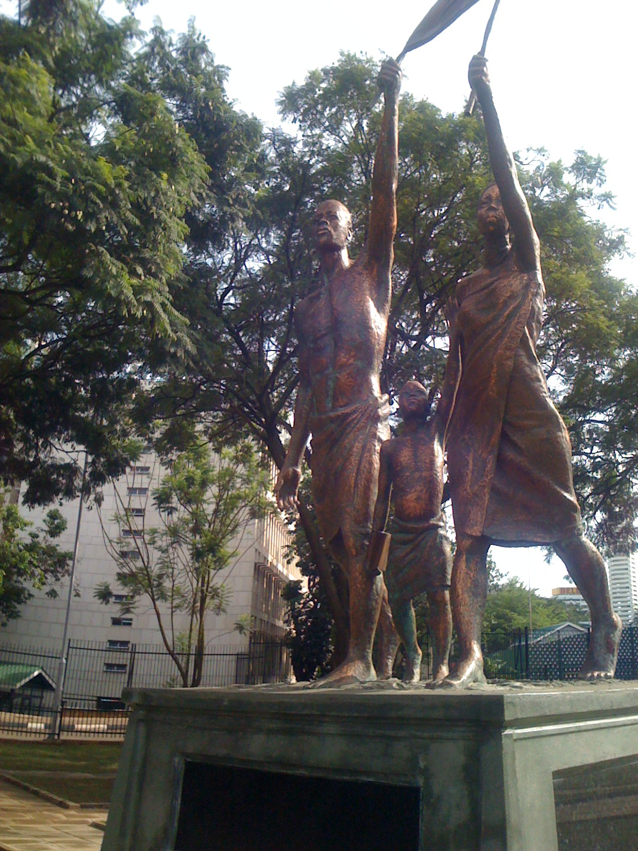

*Stride*, 2007, Kampala Uganda 17 ft. Photo Copyright George Kyeyune, (Photo taken in 2009)

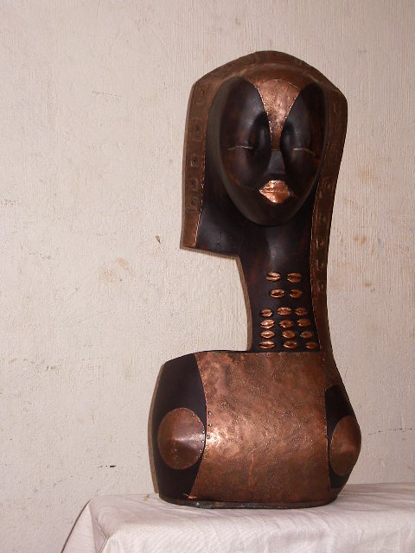

The Bride-- 3ft high, photo copyright George Kyeyune (photo taken in 2012)